+91 6302679822



1 77777 66666

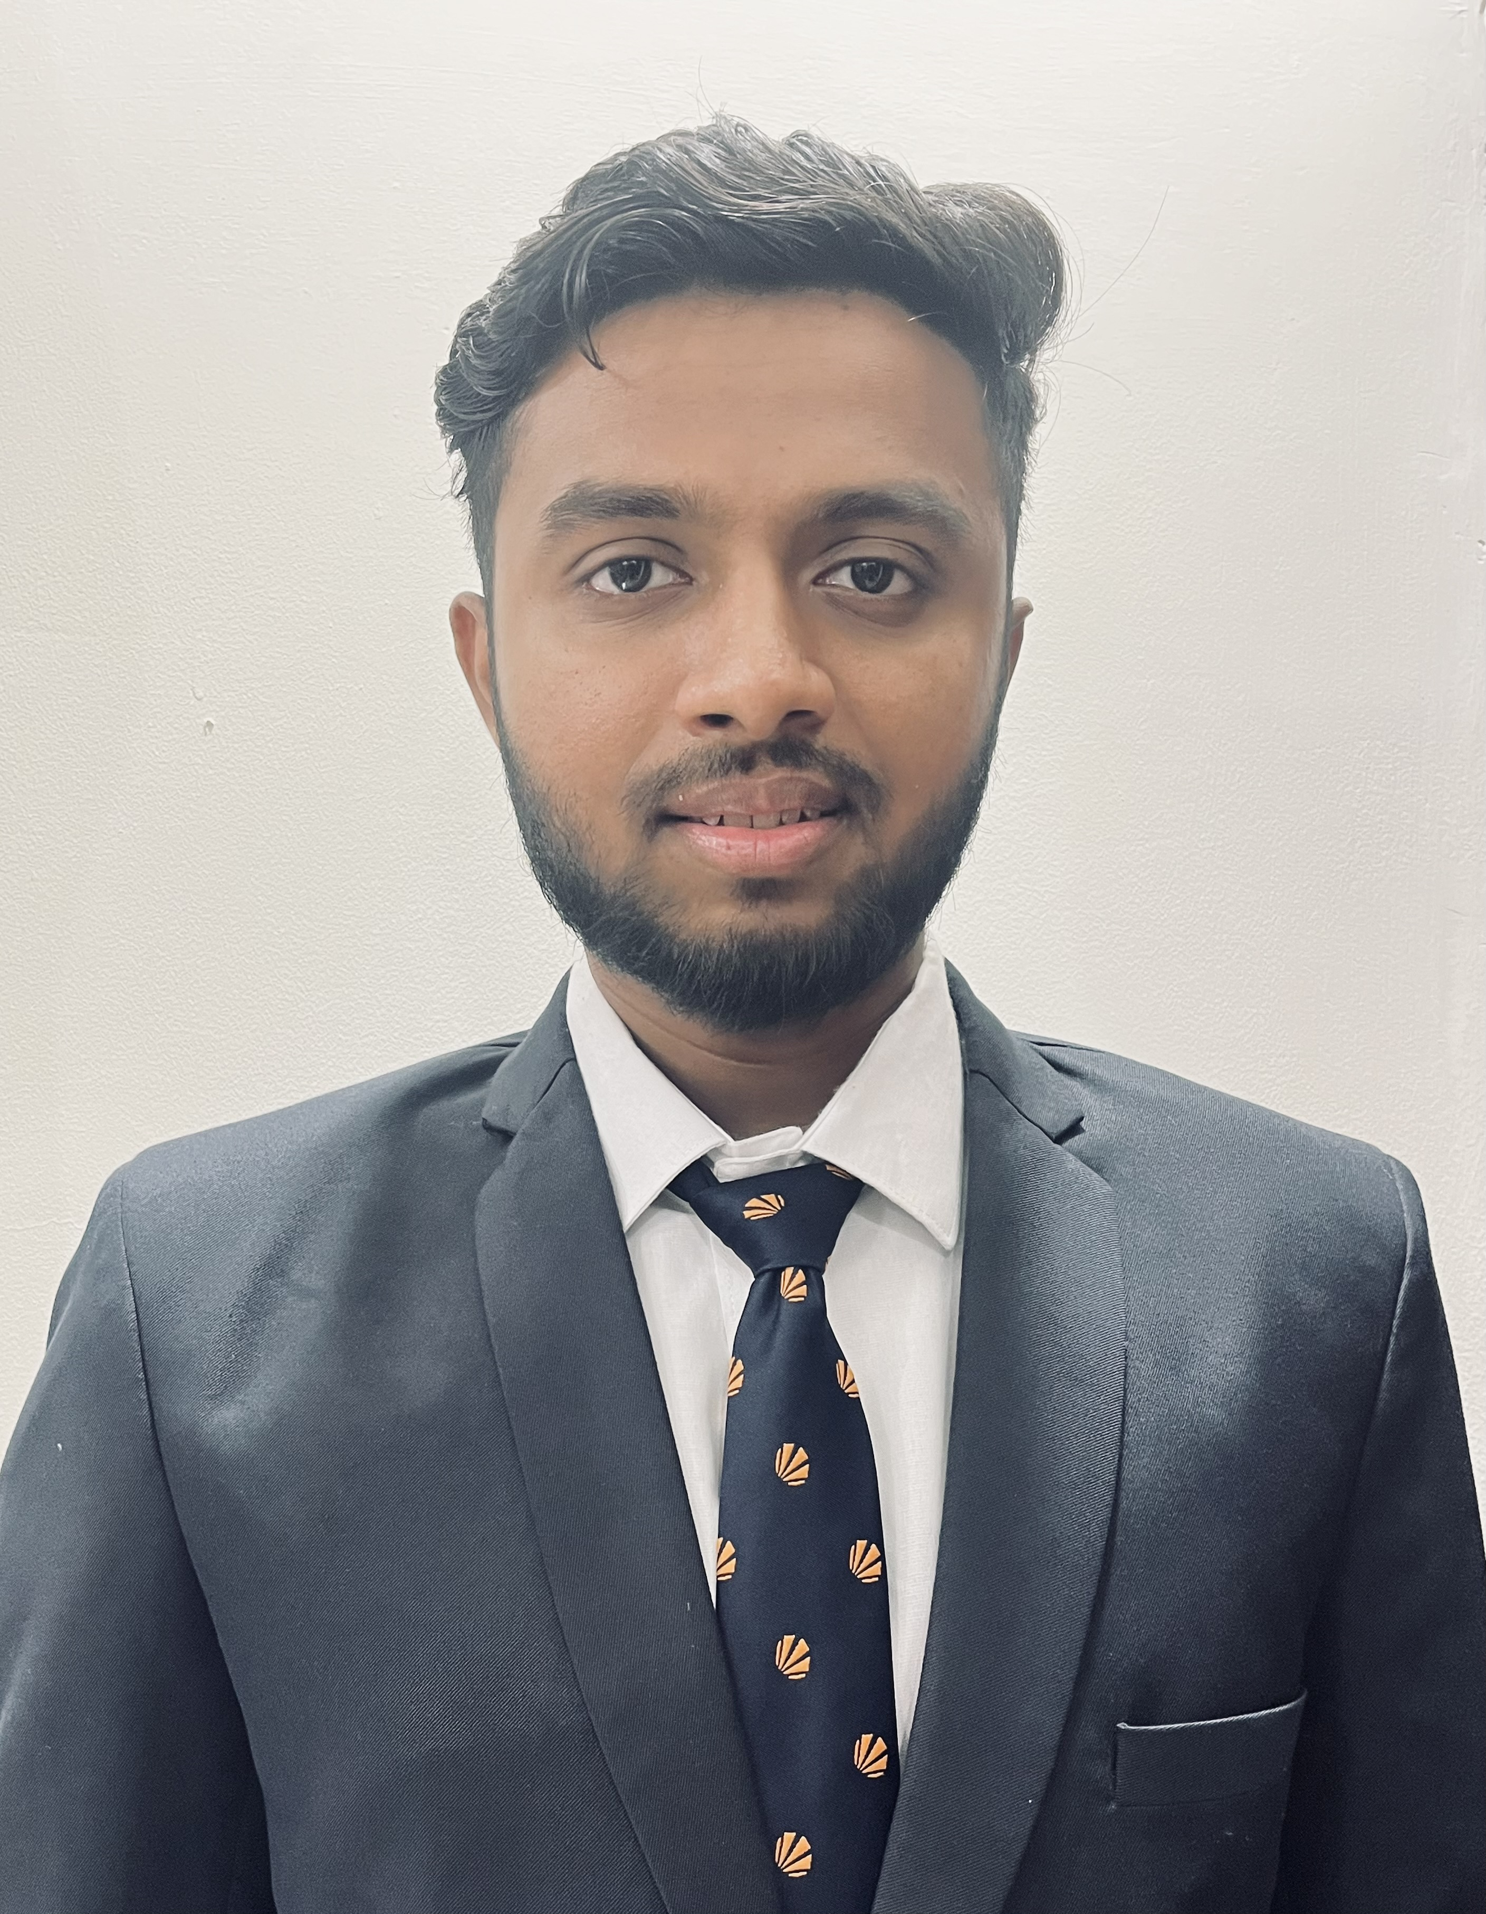

M SAIRAM VARMA

https://www.linkedin.com/in/sairam-varma07/

sairamvrm@gmail.com



Software Engineer

Kakinada, Andhra Pradesh

https://github.com/SairamVarma07



SUMMARY INTERNSHIP

A tech enthusiast, quick learner who is ready to adapt. Seeking a challenging position in a reputable company to expand and utilize my learning, skills, and knowledge. Possess excellent communication skills and have an eye for detail. Flexible to work in any environment as required.

TECHNICAL SKILLS

**Programming languages:**

Java, JavaScript

**Technologies:**

HTML5, CSS, Bootstrap, Spring Boot,

Angular Js

**Data Management:**

MySQL, MS Excel, Tableau

Desktop

CERTIFICATIONS

Data Structures and Algorithms | Geeks for Geeks| Aug '21

Java Full Stack Developer|

Cipher schools| Jan ‘23

IBM Cloud Essentials | EDX |

April ‘23

POWER SKILLS

* Analytical Skills
* Open Minded
* Leadership Qualities
* Problem Solving Skills

EXTRA CURRICULAR ACTIVITIES

• Participated in TEDx TALKS

LPU | Apr’22

• An Intermediate French

Speaker

Internship On Java Full Stack from Cipher Schools Jan’23

• During this internship at Cipher Schools, I had the privilege to immerse myself in a diverse range of

Wed development projects.

• Gained hands on experience to solve technical issues and enhancing my skills in both front end and

back end technologies.

PROJECTS

Portfolio Website Jan'22

Tech Stacks used: Html, CSS, Bootstrap

* In this project, had used Html, Css and Bootstrap to design my own portfolio website, so that everyone can know about me better.
* The layout I’ve used is clean, modern, and visually appealing.
* Designed with a user centric approach, the website reflects my unique personal brand and my ability in website design.

Email GUI (Front end Application) Feb ‘23

Programming languages used: Angular Js, Html, Css and Bootstrap

* Created an email sender app with help of Angular. It’s a front-end interface where you can send mail to anyone across the globe.
* This project allowed me to demonstrate my knowledge in software development and user interface design.
* It involves designing and implementing a user-friendly interface for accessing and sending mails to anyone.

Sudoku Solver June '22

Programming languages used: Java.

* The project involved developing a program capable of solving Sudoku puzzles of varying difficulty levels.
* I utilized my knowledge in java, to implement the solver algorithm based on the backtracking approach.
* This approach involves systematically trying different possibilities and undoing incorrect choices until a valid solution is found.

ACHIEVEMENTS

Participated and reached 2nd Milestone in a Hackathon conducted by

Programming Pathshala Sep ‘22

Solved 150 + problems in geeks for geeks and have overall coding score 624.

EDUCATION

B.Tech. in Computer Science Apr '20 - Present Lovely Professional University | Punjab

CGPA 8.1

Higher Secondary Aug ’18 – Mar’20 Narayana Junior College | Andhra Pradesh

CGPA 7.8